

Content
Logo 1
Images 1
Home Slider 1
Banners 2
Static pages (photo/text) 4
Social Networks 5
Properties finder 5
Elements to highlight 8
Featured properties 8
Area of influence 10
Team 10
Blog/News 11
Other: testimonials, capture leads, newsletter, properties acquisition... 13
Featured sentences for the home slider 18
Listings page 19
Print | PDF 22
Newsletter 26
Printed graphic material 30

Content Guide
We want to do exactly the site you're looking for your business. And to do that we need basically two things:
- An attractive quality for inclusion in the website content.
- Know your opinion on certain aspects of the web.
To facilitate the task we have prepared this guide with some recommendations and very specific graphic examples, do we start?

Logo
To start working, we need a version of the logo with the highest possible quality. Ideally have it in vector format (.ai or .eps).
The logo is very important because, generally, the color palette of the website is chosen based on the logo.
The first thing you need is a good logo and your preferences about the color palette.

Images
One of the fundamental pillars of the web. The images make the difference between an attractive and professional web and any web, the heap.
In the following article (Spanish) we explain the importance of using professional photographs within the web development:
Why is it important to use professional images on your website

Home Slider
The images have to be at least 2000px wide and be in widescreen format. They must be attractive and professional, will be the first thing users see when they land on the website.
Let's see examples:
Widescreen: YES
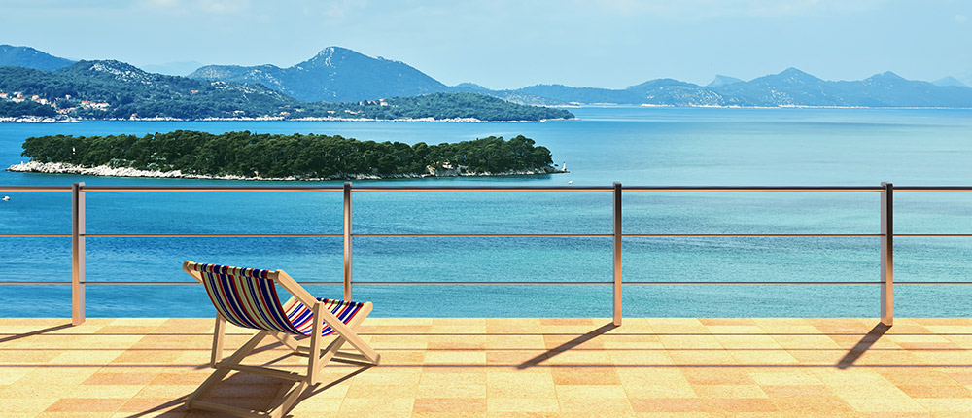

Widescreen: NO


Banners
There are many types of banner and ways of presenting them. Once we know which products are those that want to stand out, the next step will be its presentation.
I leave some examples.
Row with 2 images (panoramic format):
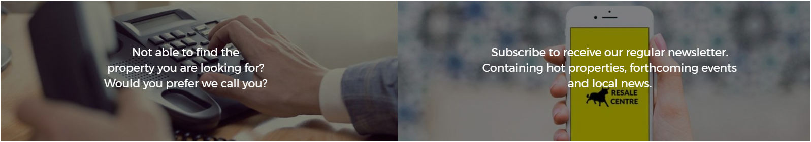
Row with 3 custom designs:
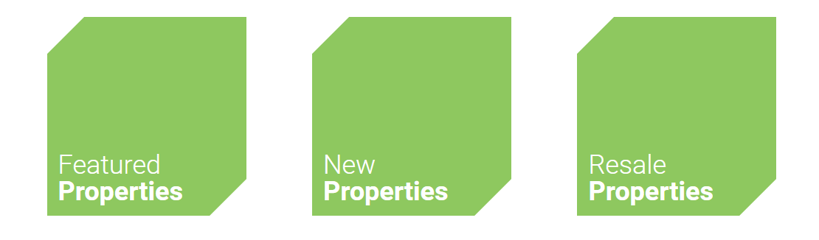

Row with 2 images:
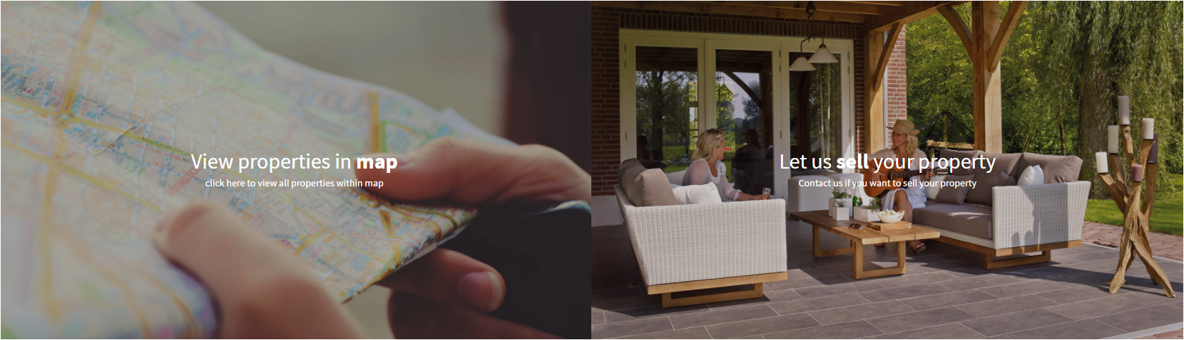

Mosaic:
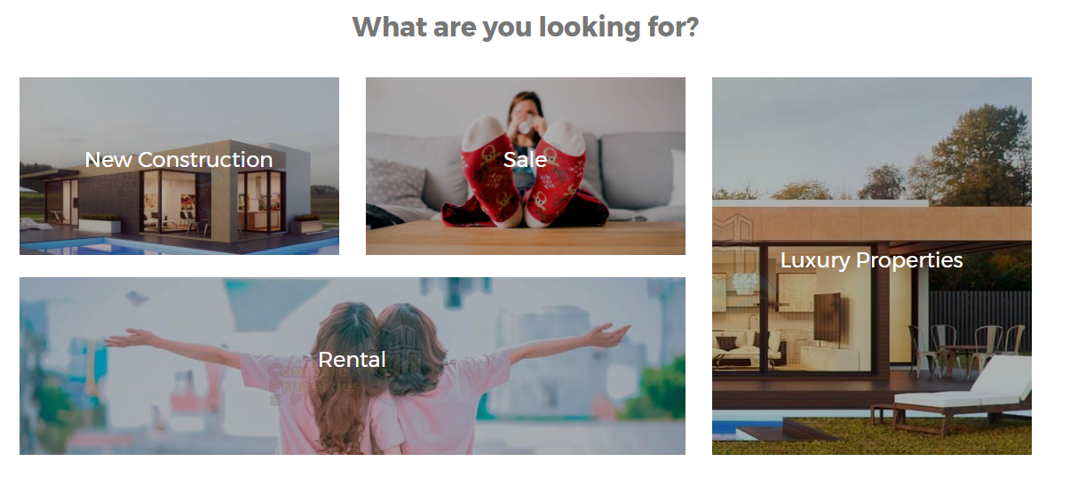

Row with 3 images:
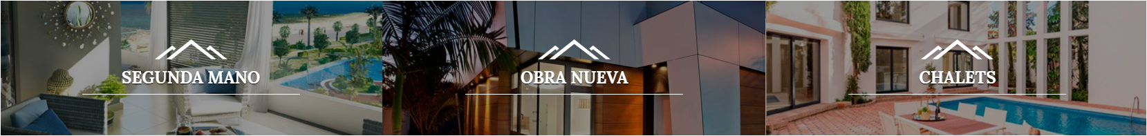

2 Rows with images:
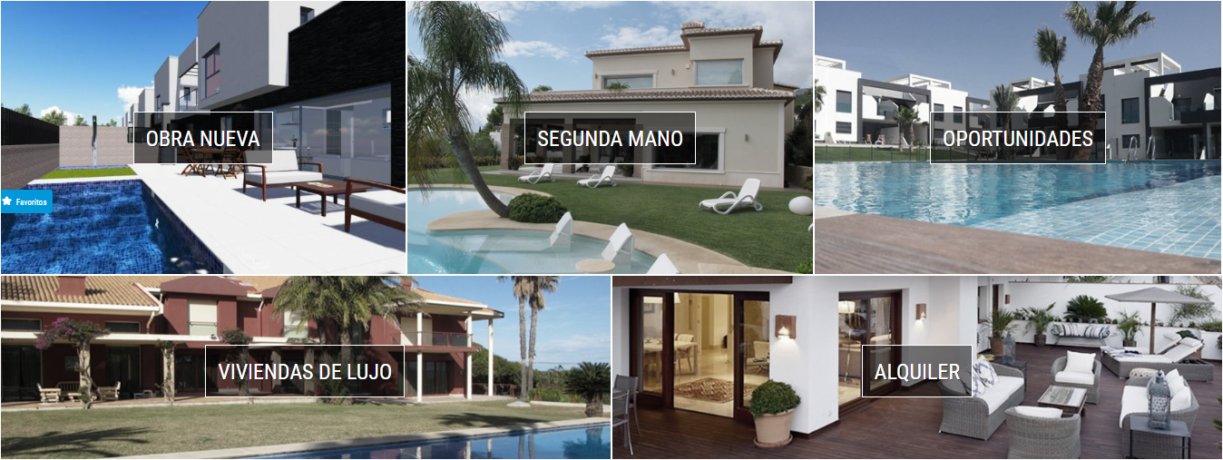
Minimal design. Row with 4 little icons:
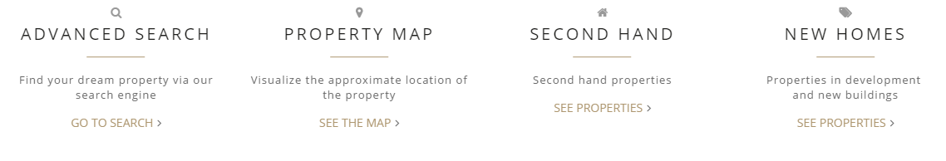
Banners + Newsletter:
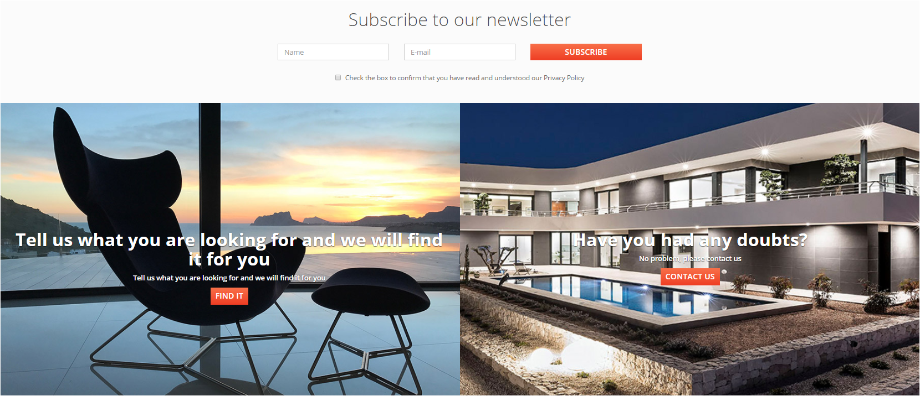

*What option do you prefer?*

Static pages (photo/text)
Mediaelx Web Design recommends adding images to the different static pages that will form your website. Examples might be:
- About Us / About Us / Company
- Buyers Guide guide seller ...
- Services
- Area Information
- ...
They shall enable a more attractive and professional web appearance. As for the usual requirements: attractive and quality.
Quality is something that is always better than on, never missing ;)
More examples before finishing with photos:
Example page legal services:

Example page with information about the area, golf courses:
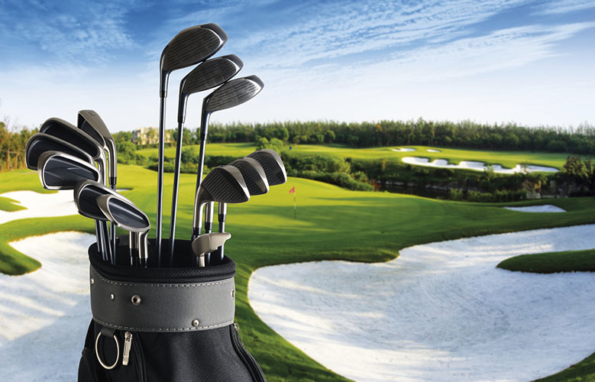
Buying guide example:


Social Networks
If you want to include links to corporate social networks of your company you should provide links of each one: Facebook, Twitter, Google Plus, YouTube...
If you need help with this we can lend a hand. Contact us and we will speak :)

Properties finder
The engine of any real estate website. The search engine is the tool that users start searching for the home of their dreams, hence its importance.
The search criteria that can be included and how to present it may be varied. Here are some examples:
Finder above the slider:
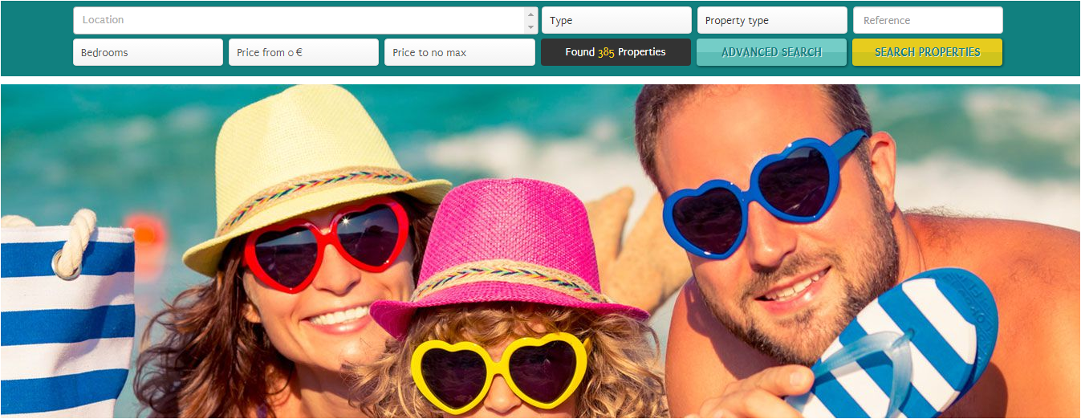

In the center of the slider:
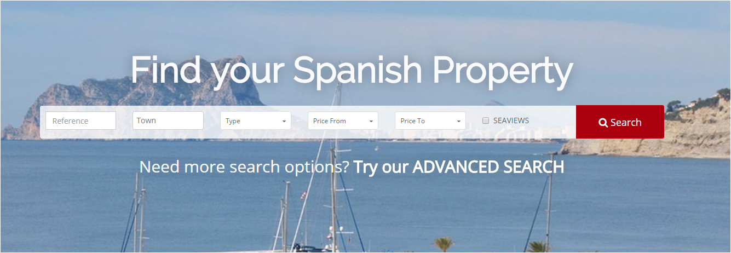
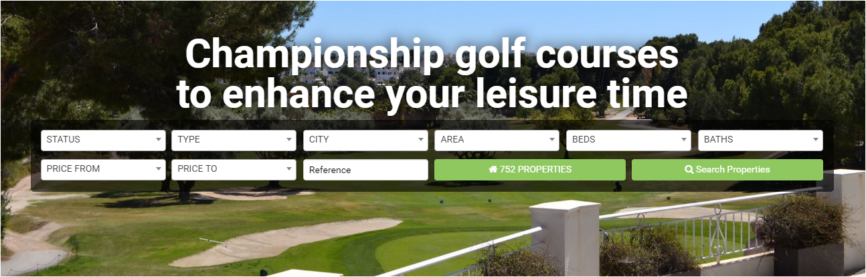

Finder on the bottom and included within the slider:
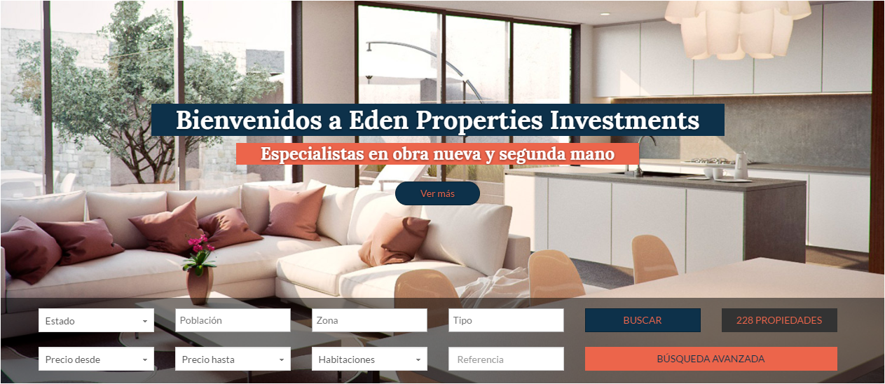

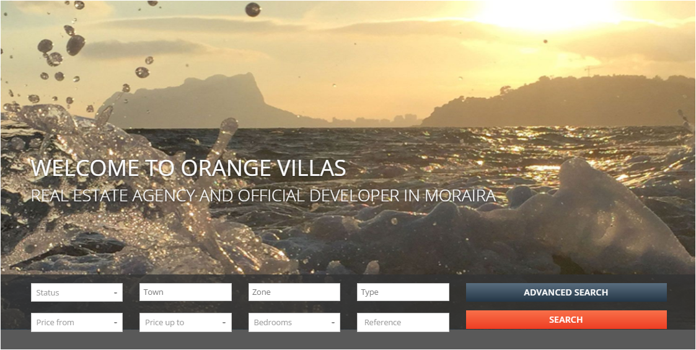

Finder in the bottom of the slider:
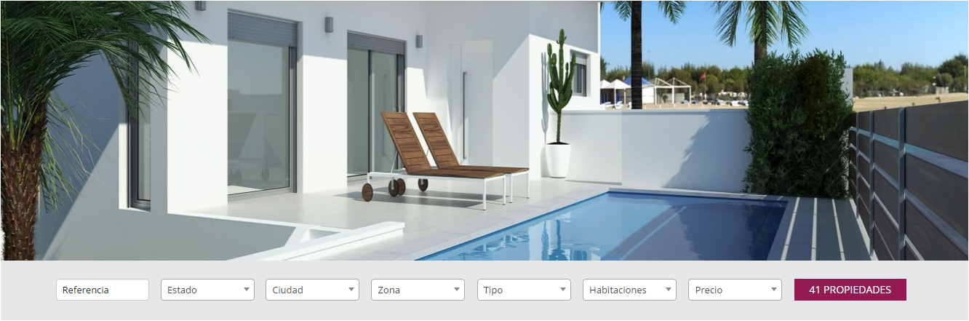

Vertical Finder:
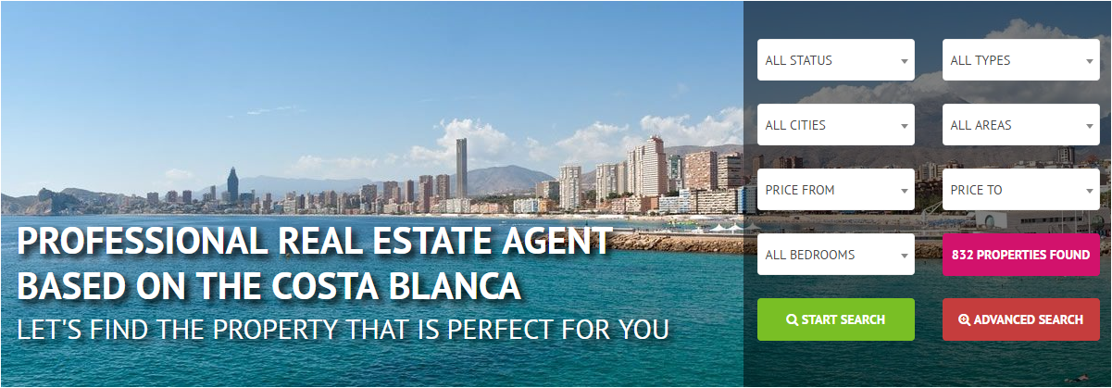
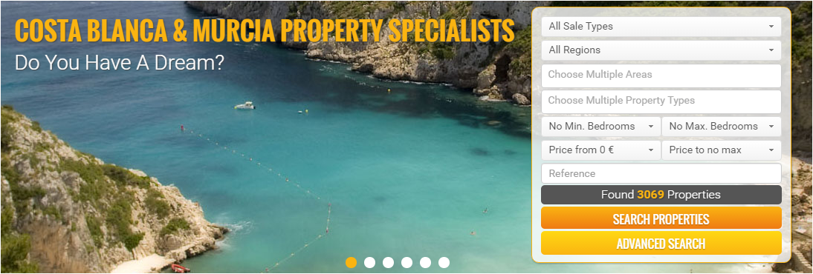

*What option do you prefer?*

Elements to highlight
In this part we will see what elements are what you would emphasize more on the web, on the home page for example. Needless to say what we will see are only examples and proposals, we are always time to add what you need.
Yes it is true that in the world of web pages there are a number of common elements that should not ignore. If you have any questions just talk to one of our experts, we will be happy to assist you.
Here are some examples...

Featured properties

Row with 2 properties:
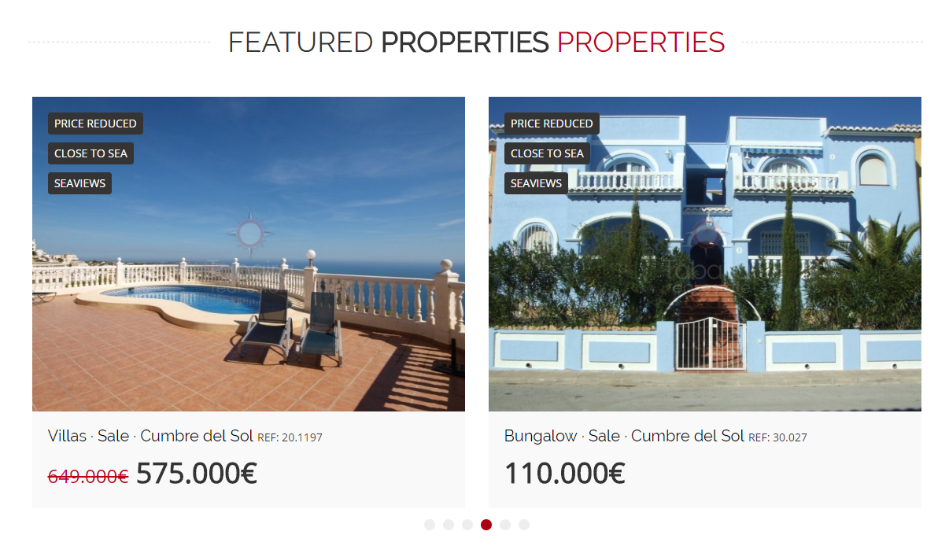
Row with 3 properties:
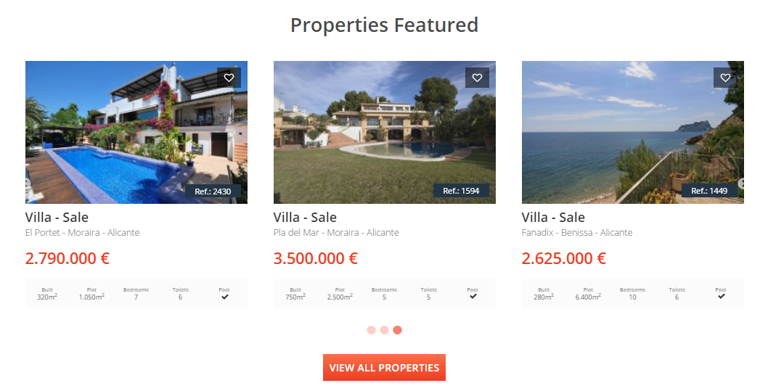
Row with 4 properties:
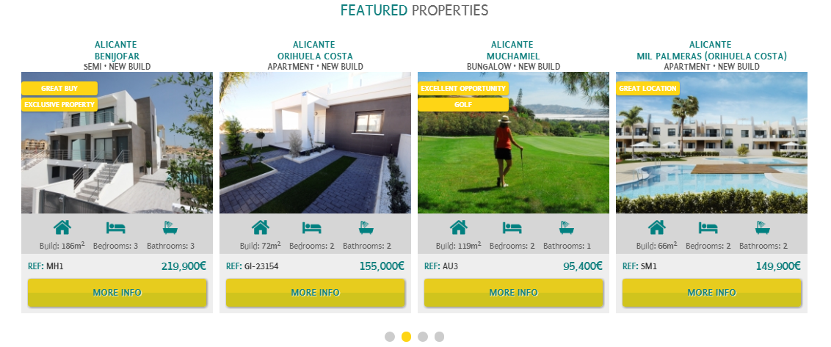
Another option is to differentiate the properties by type, look at the following example:
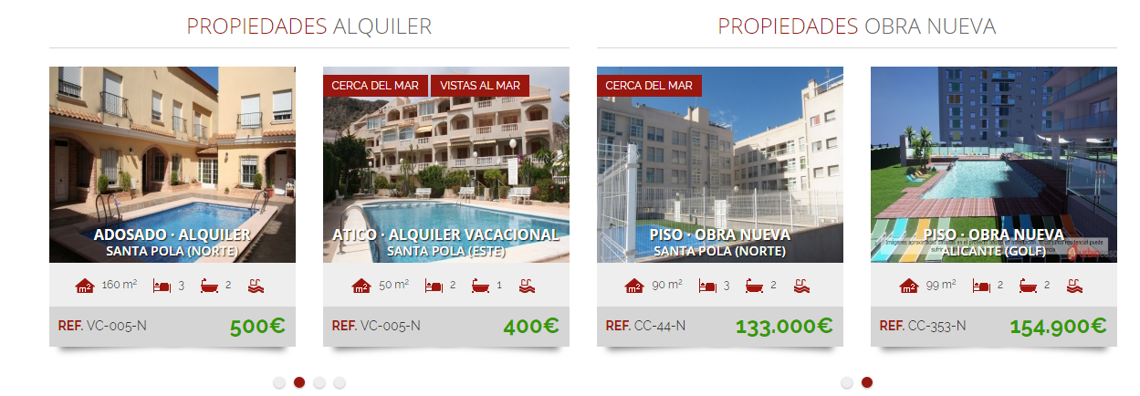
Or highlight a unique property as the property of the month, week, special offer...
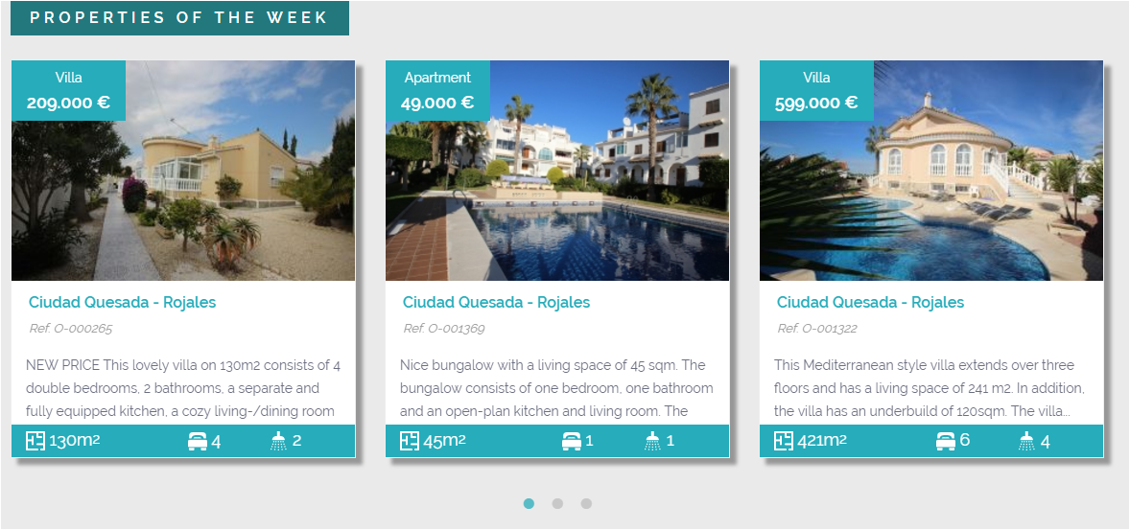
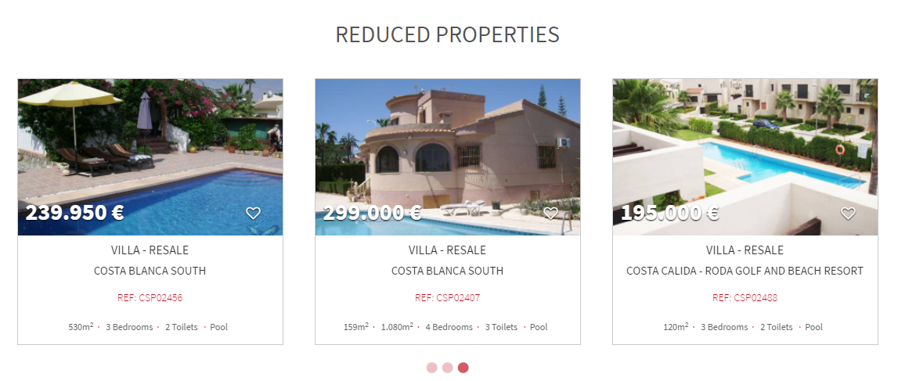

Area of influence
For example including a block with a map:
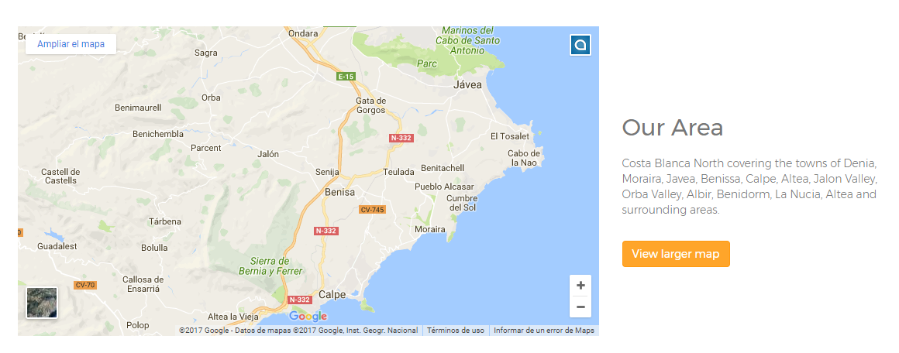
Or with a banner:


Team
We have several possibilities for this block:
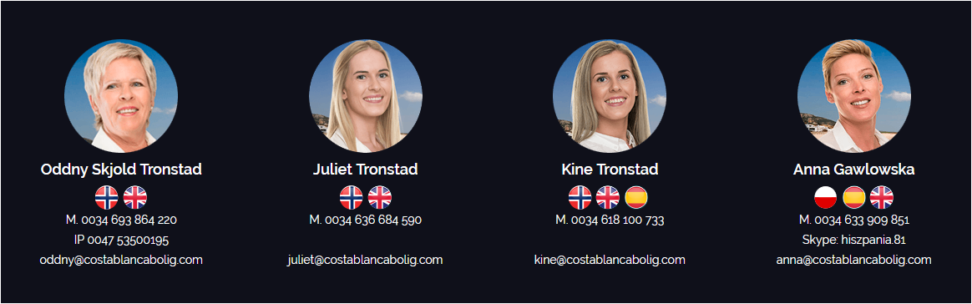

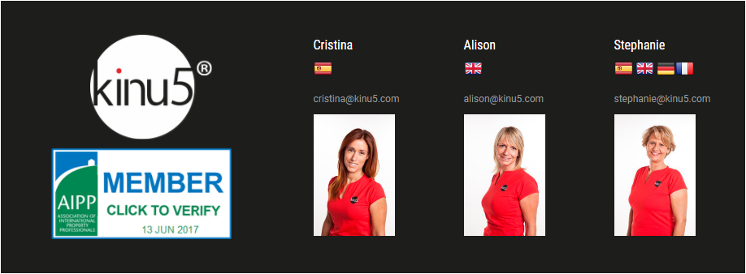

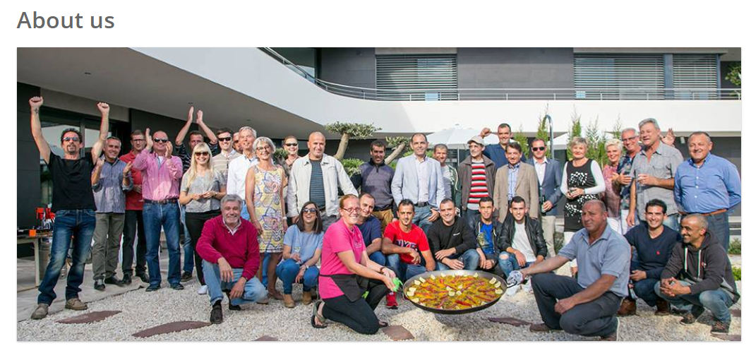

Blog/News
We start with an example in which we see one block formed by the last 2 posts of the blog:
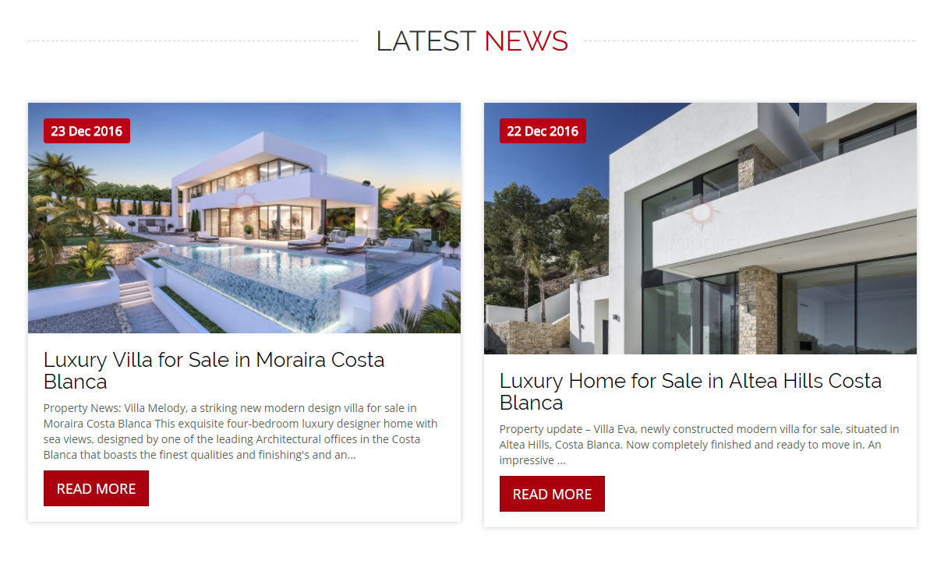
As you see the possibilities are vast, all depends on your preferences and needs of your business.
Here is another example with one new:
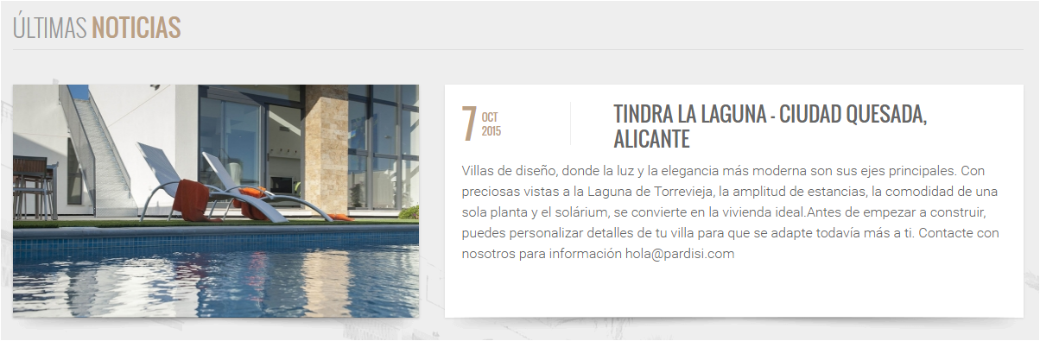
2 News:
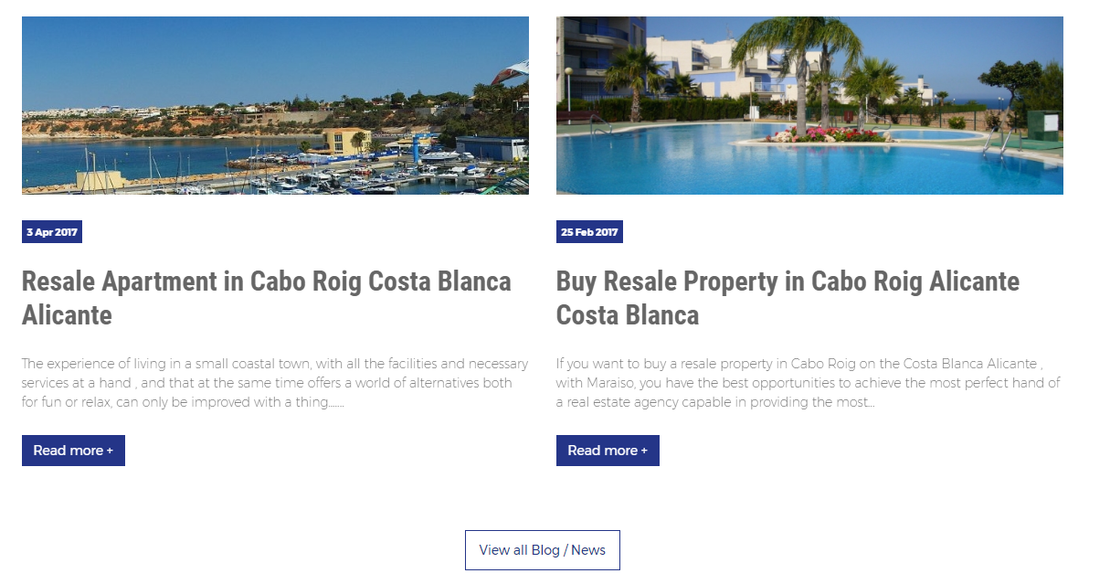
2 News vertically:
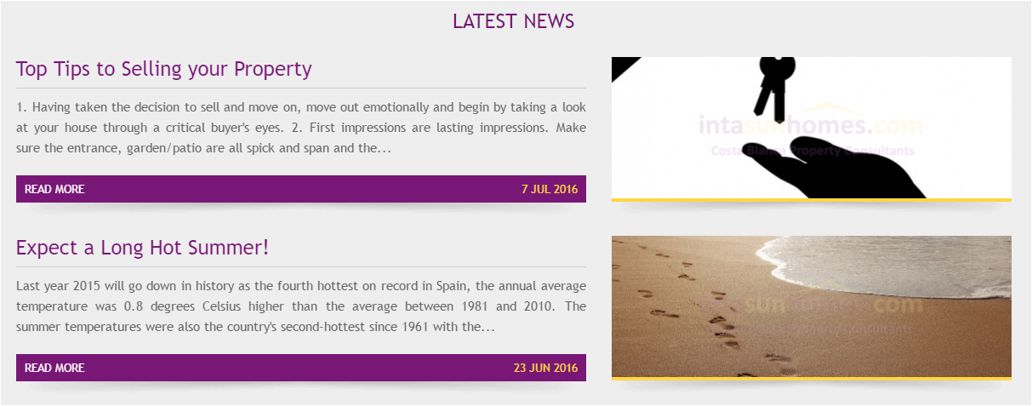
3 News
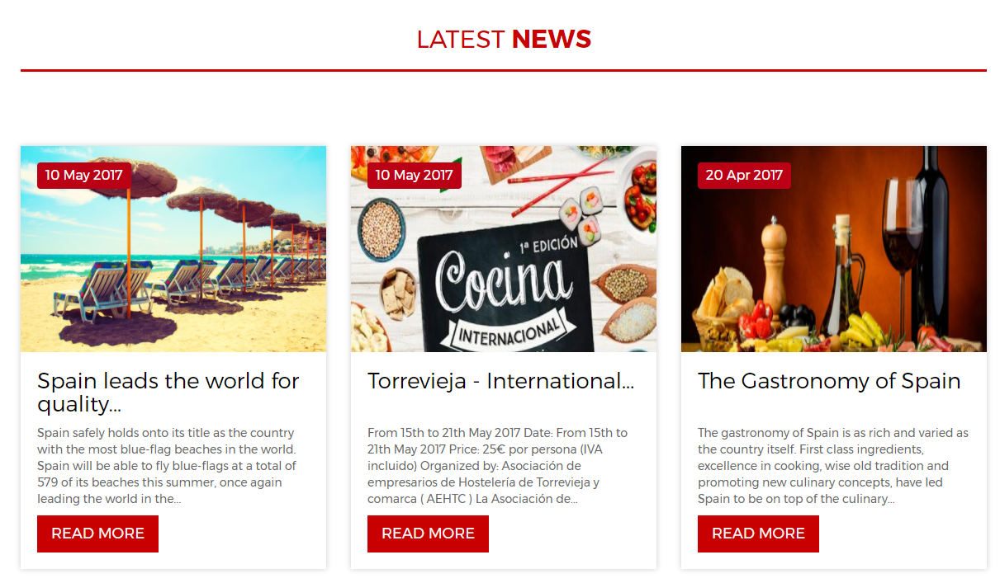
Even 4:
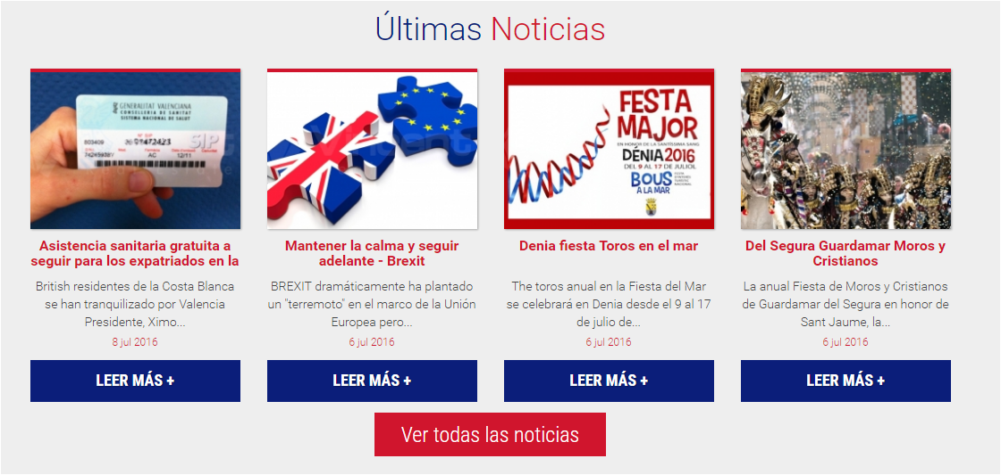

Other: testimonials, capture leads, newsletter, properties acquisition...

-Testimonials:
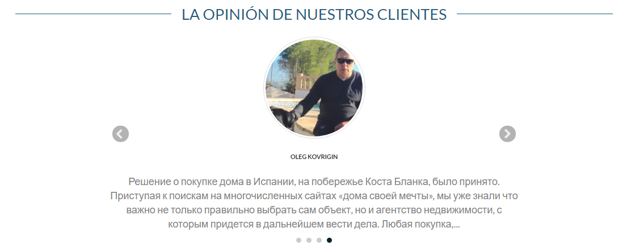

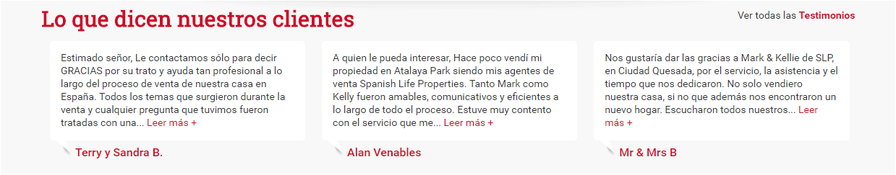

In this case the testimonials with the latest blog articles are combined in the same block:
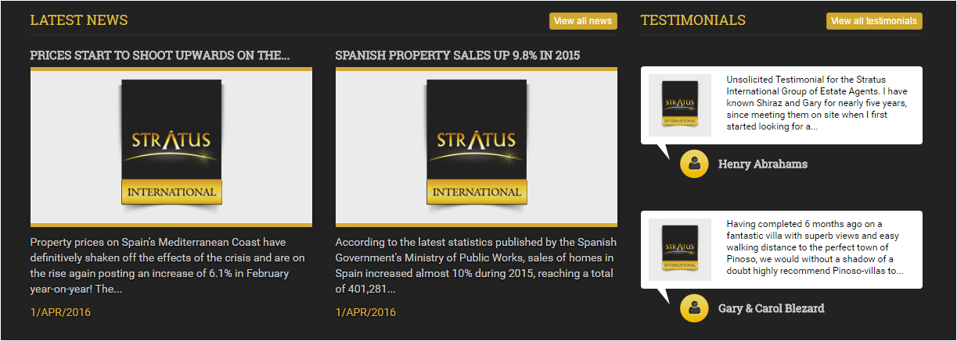
-Getting leads:
*Asking for a call back:
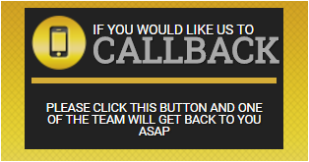
*Here is a block with 3 distinct parts:
- Call Request
- Downloading an eBook
- Newsletter
Very interesting to increase the number of leads.
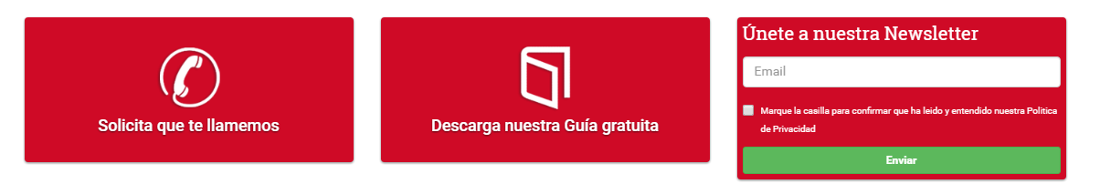
*Inspection trips:



Map + Inspection trips + Newsletter subscription:

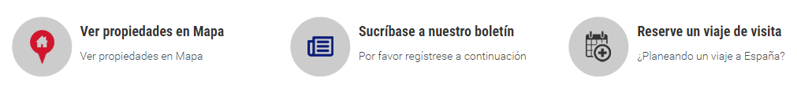

*Offering help forms:
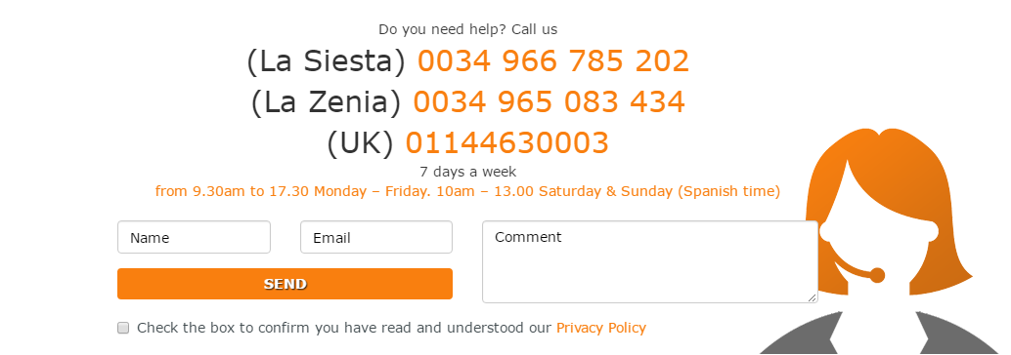

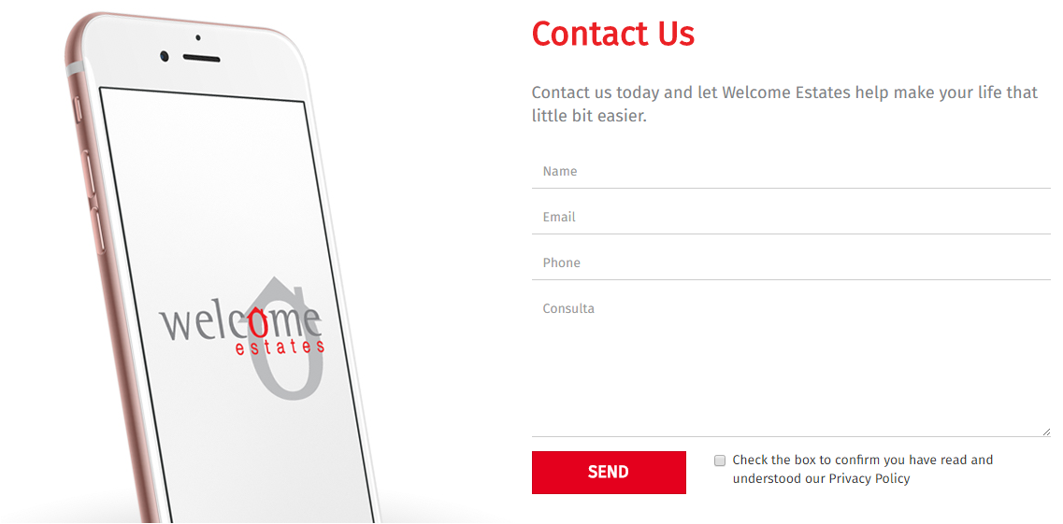

Newsletter:
We start with an example of subscription popup. You click on the button:
And the pop up appears:
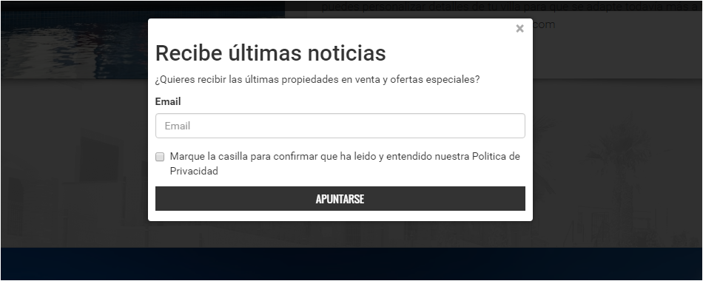

More examples:
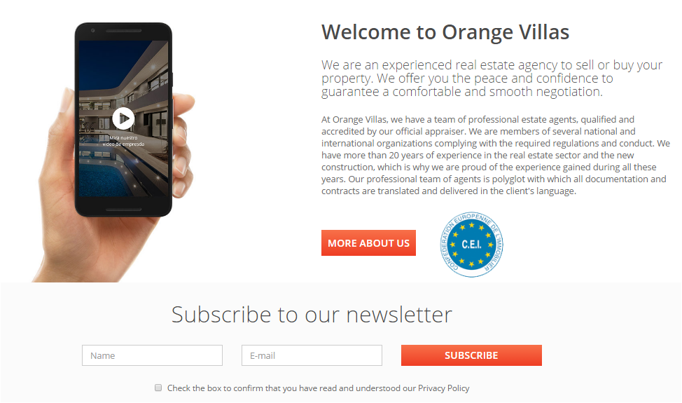
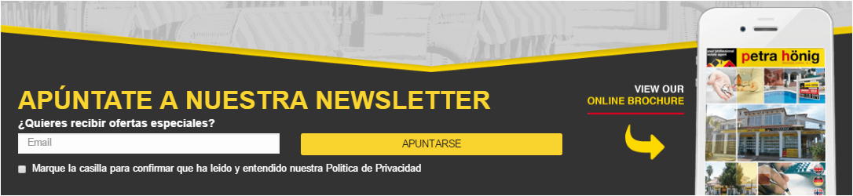
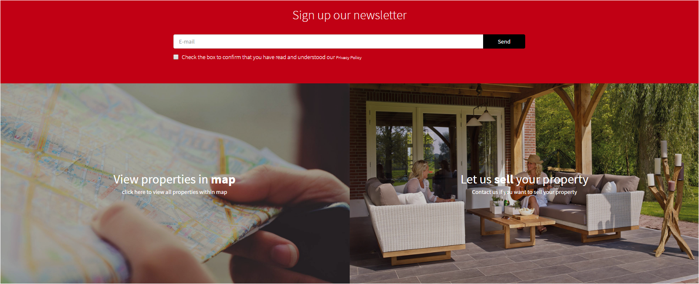

Properties acquisition:
Banner:

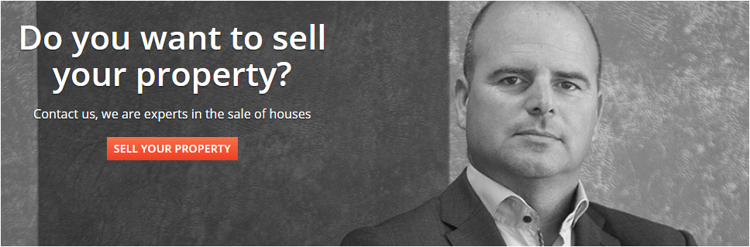
As slide in the home page:
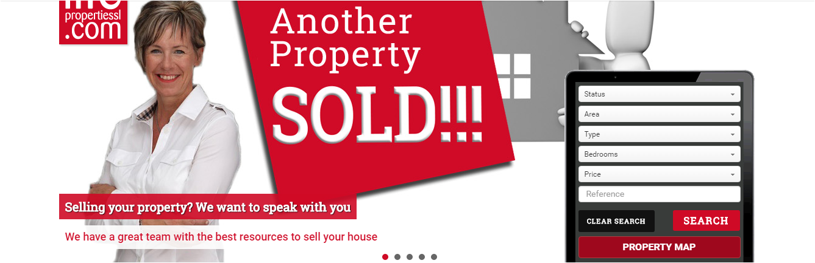

NOTE: If you have a specific requirement speak with us, we will be glad to help you.
Finally here are some customised blocks examples:
*Building Services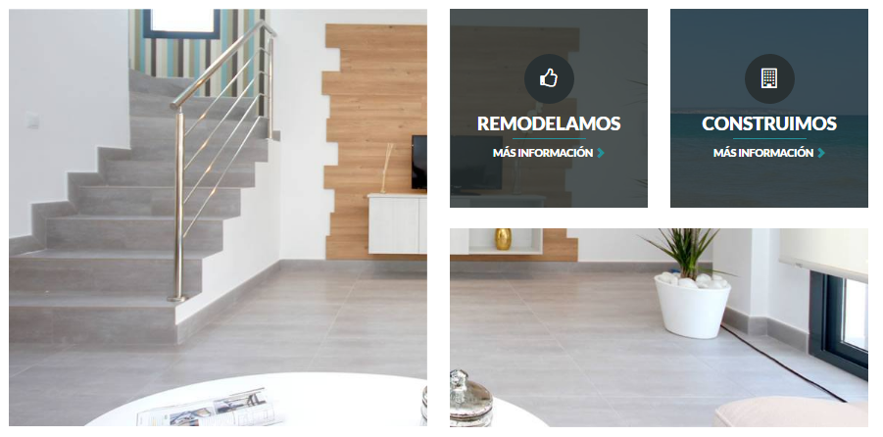

*News + Event Calendar + Work with us
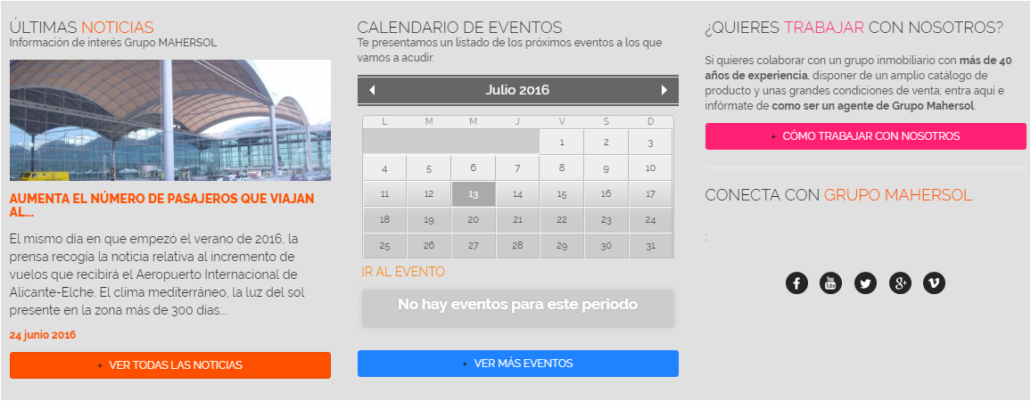

*Franchises


Featured sentences for the home slider
They are very important, it is the first thing that the users will read in the website.
Examples:
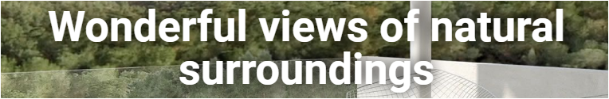
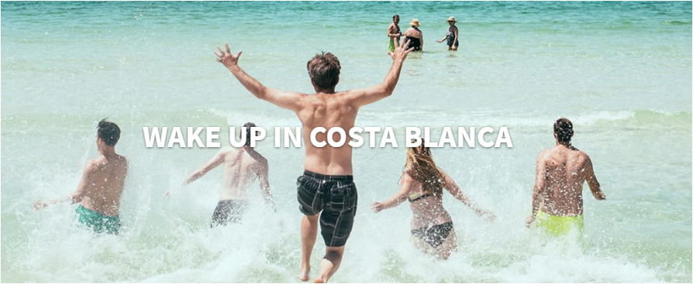

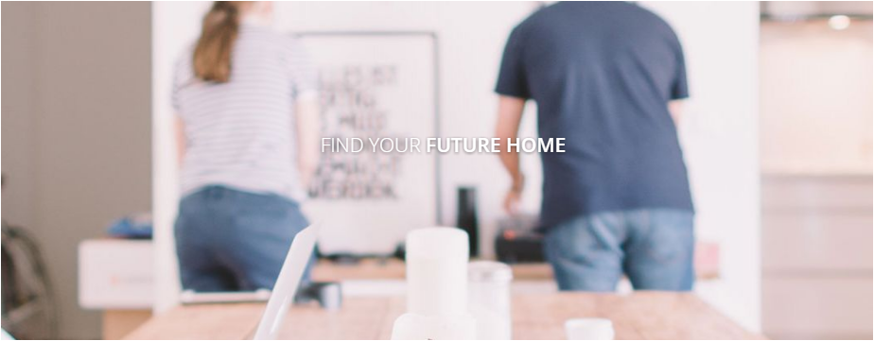
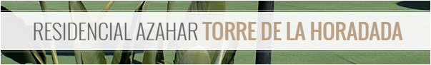
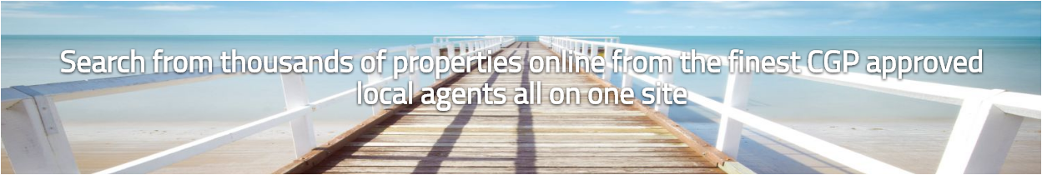



Listings page

1 Listing by row
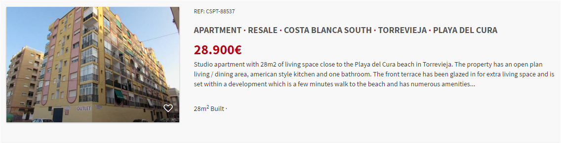
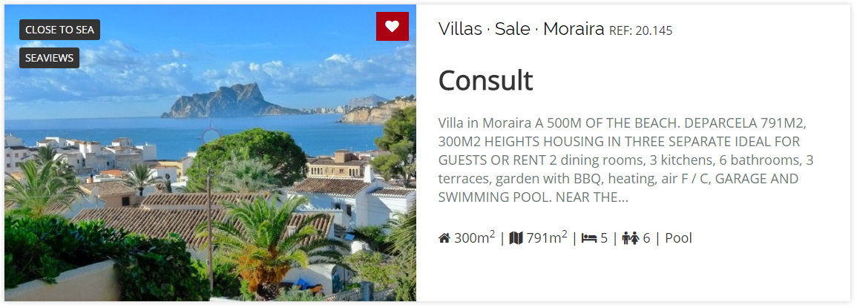
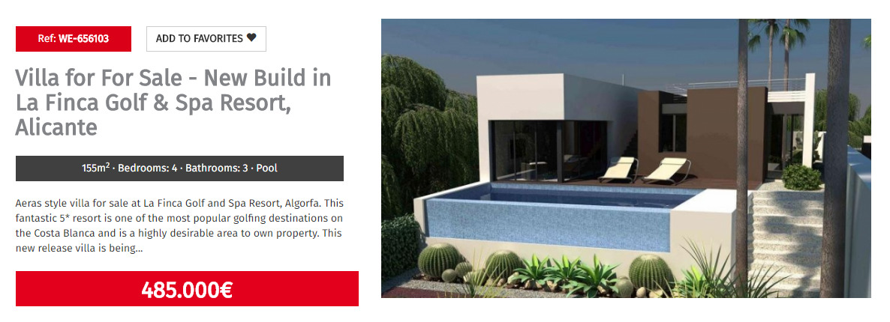
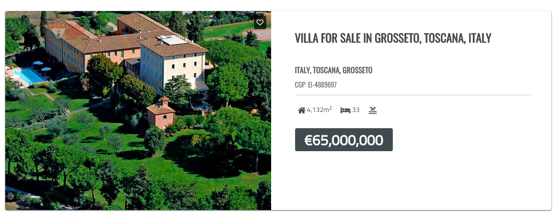
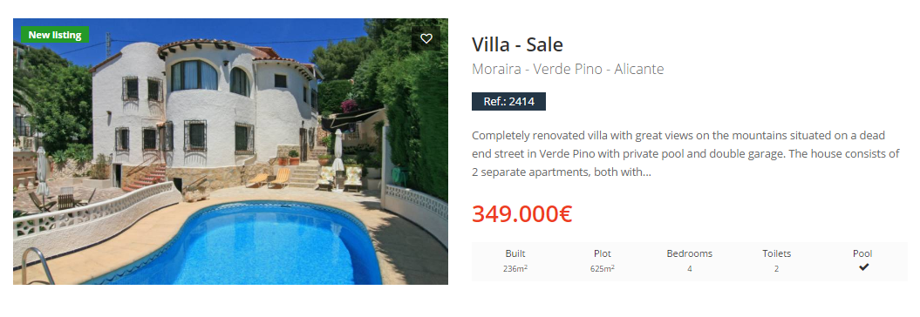

2 Listing by row
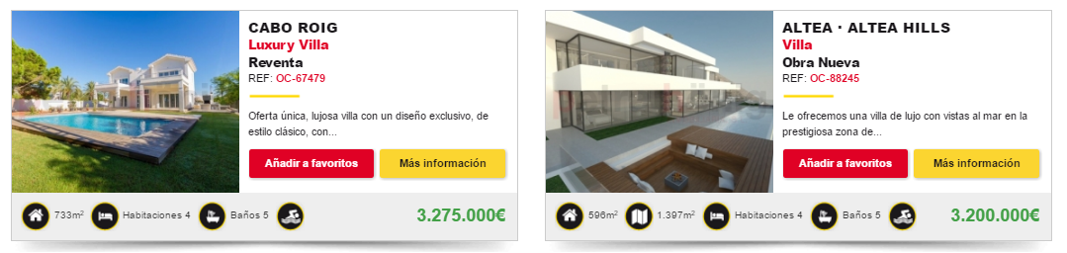
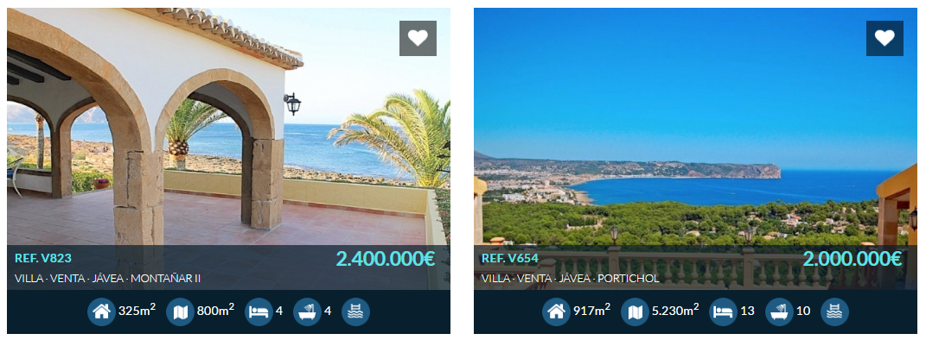
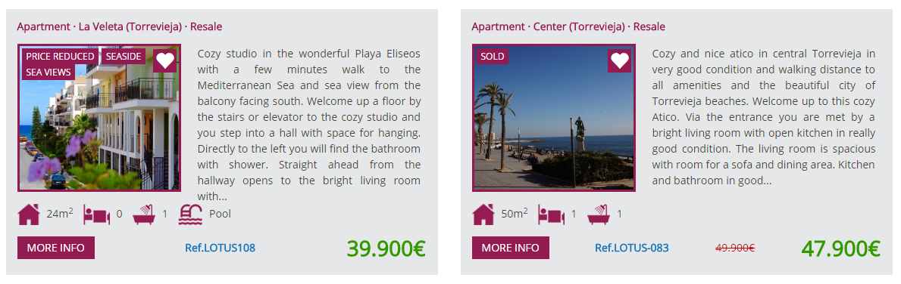
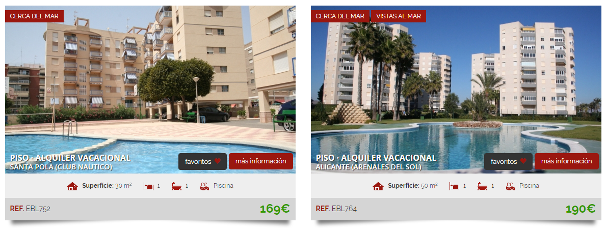

3 Listing by row
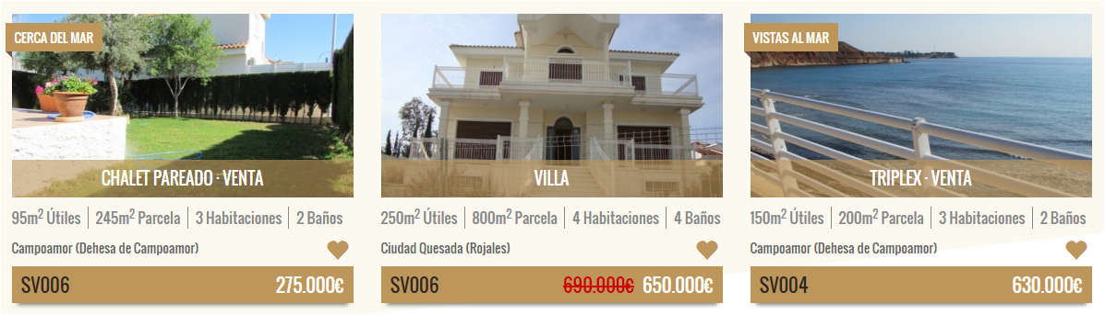
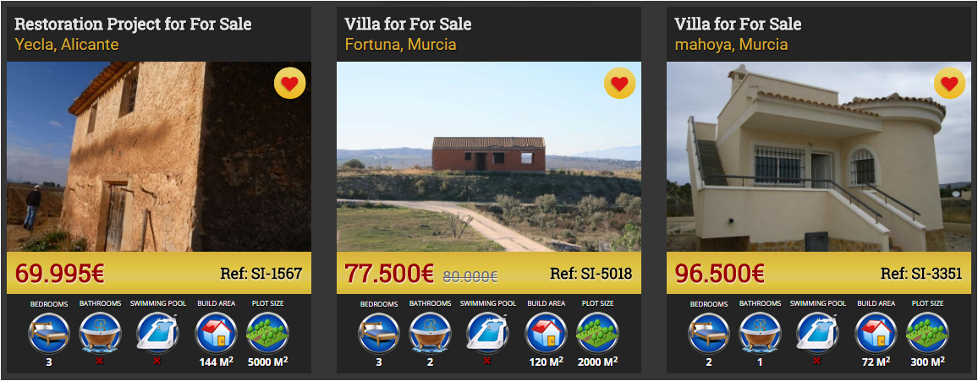
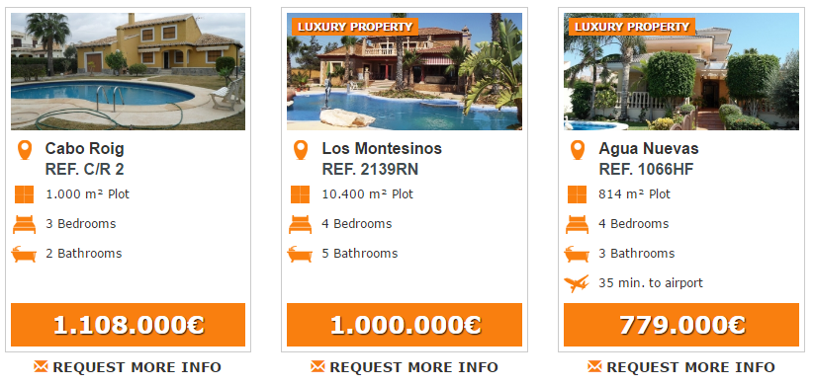
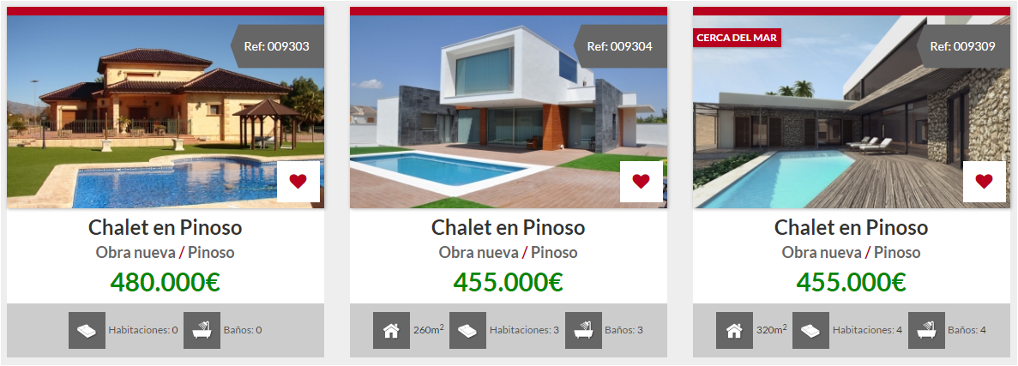

Print | PDF
Here we present 4 templates that you have at your disposal to print cards of your properties: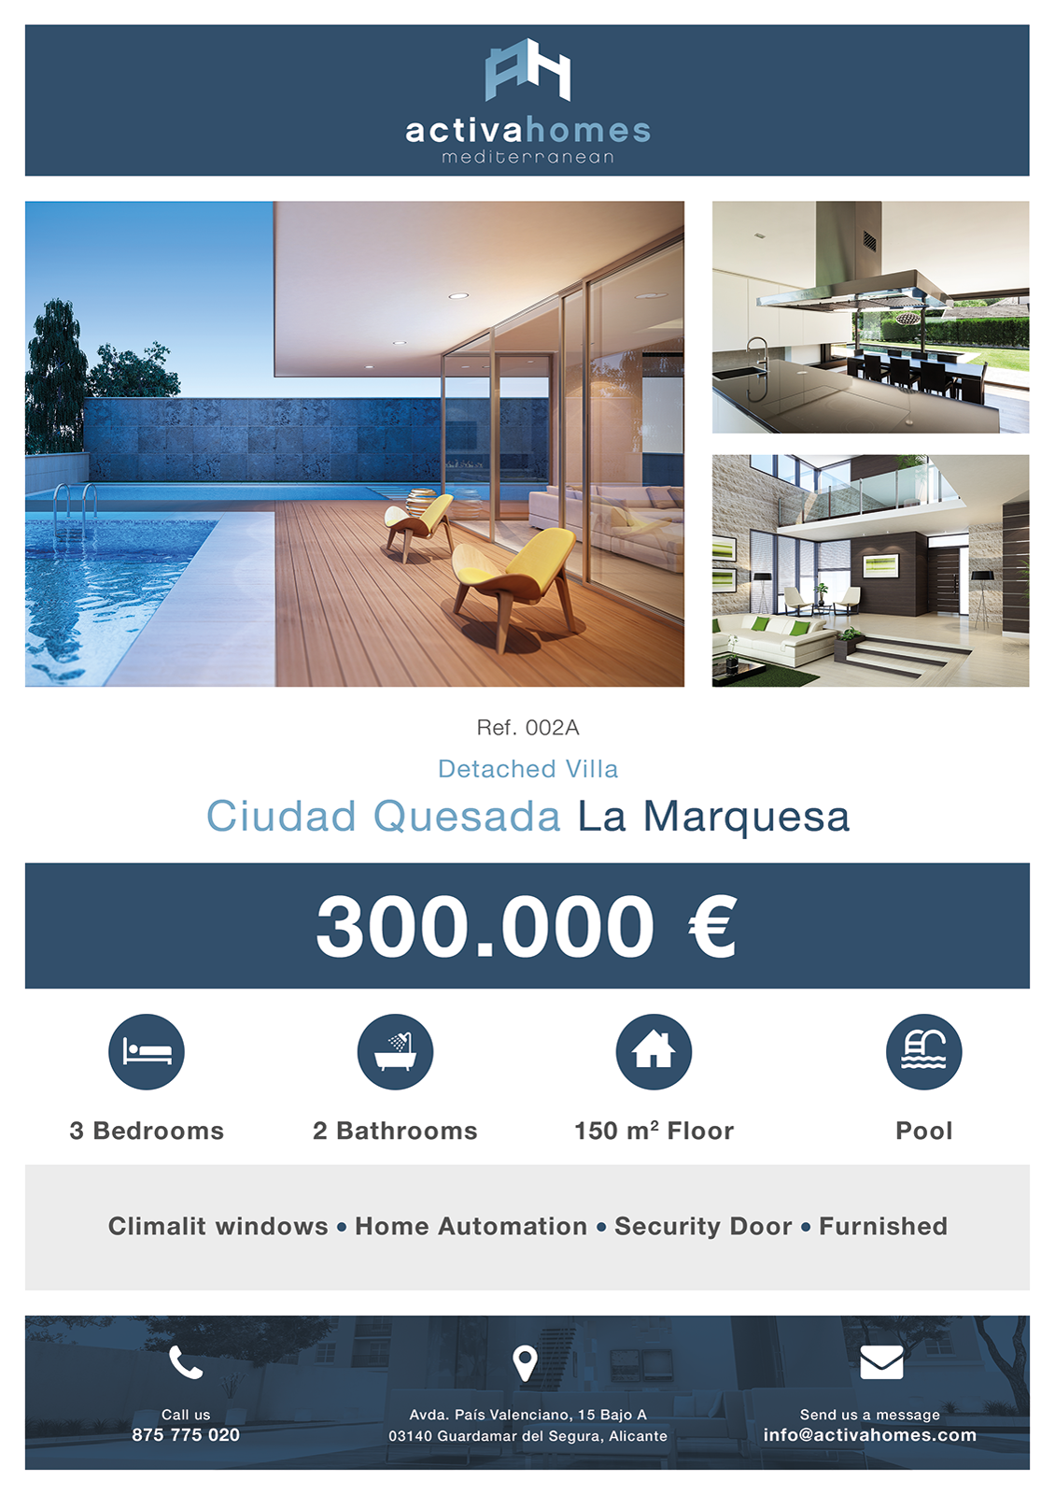

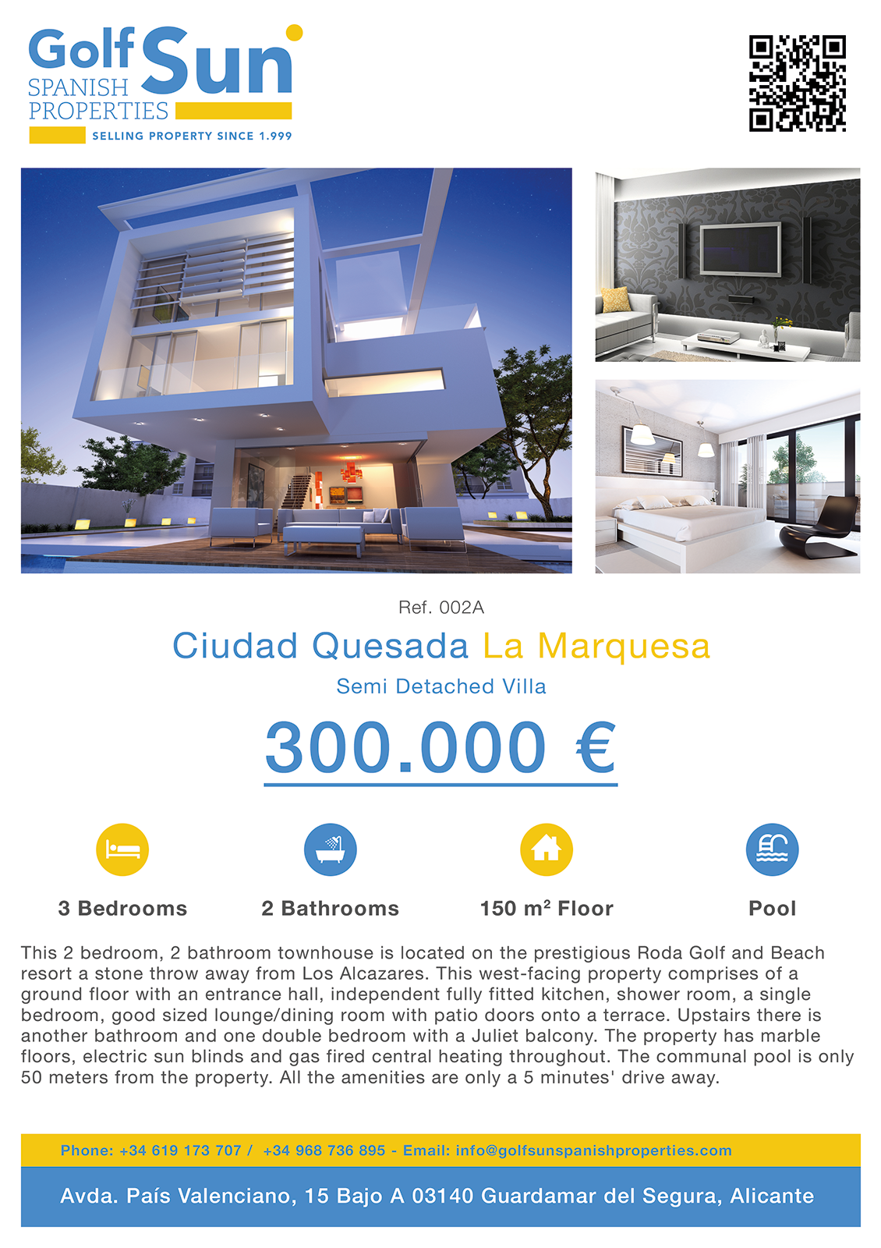

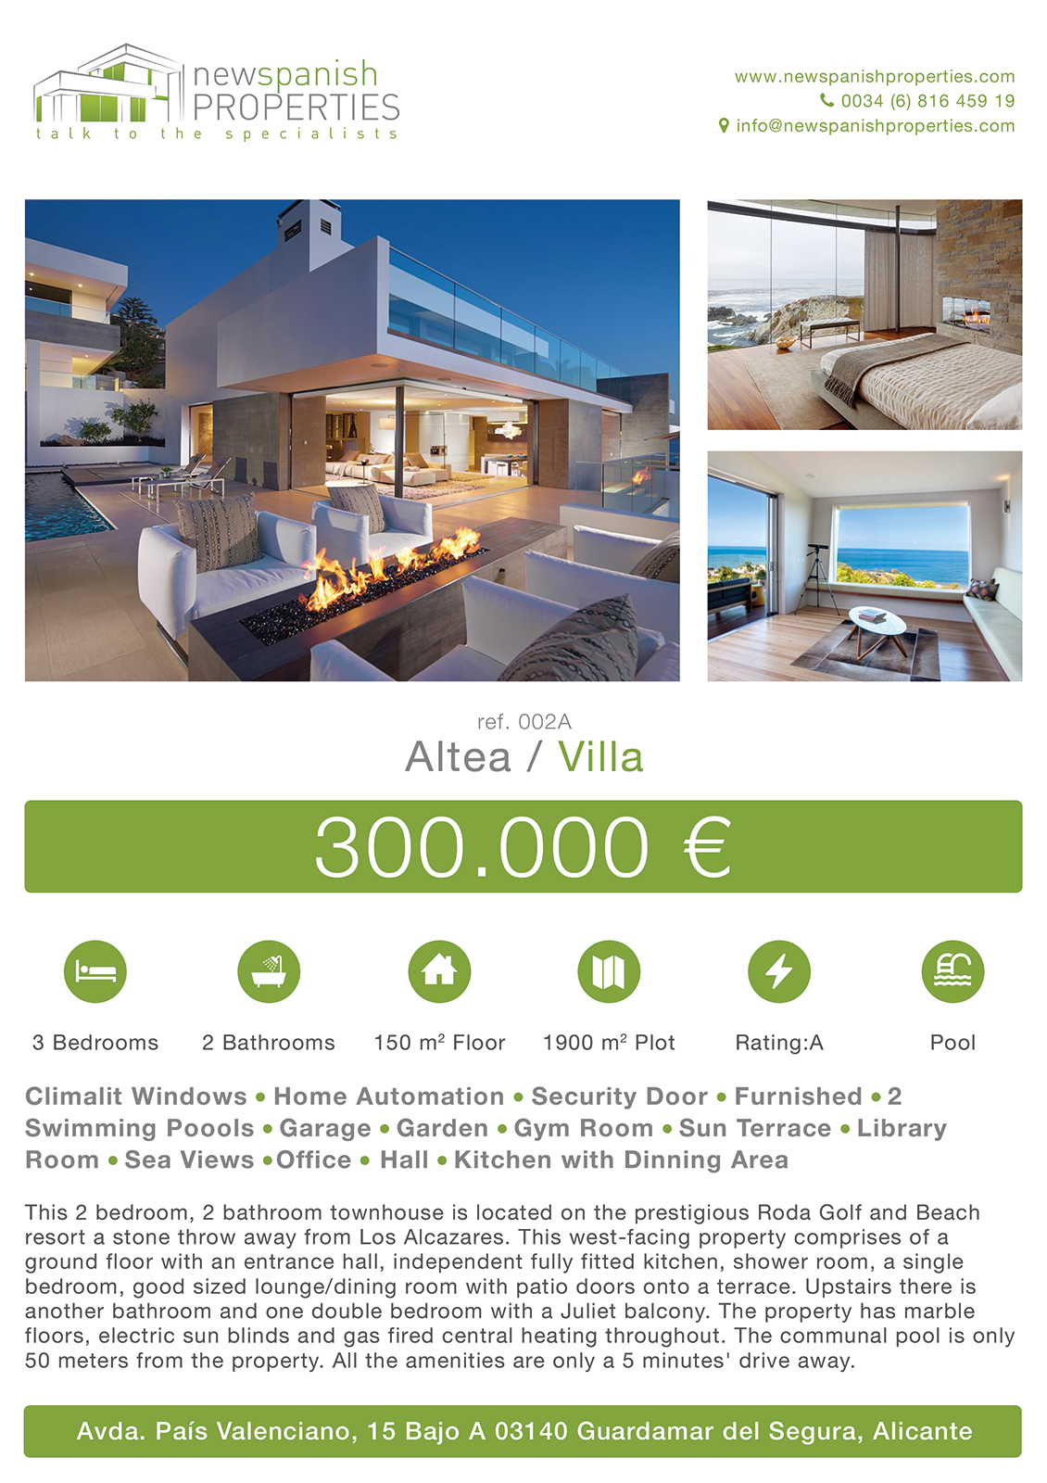

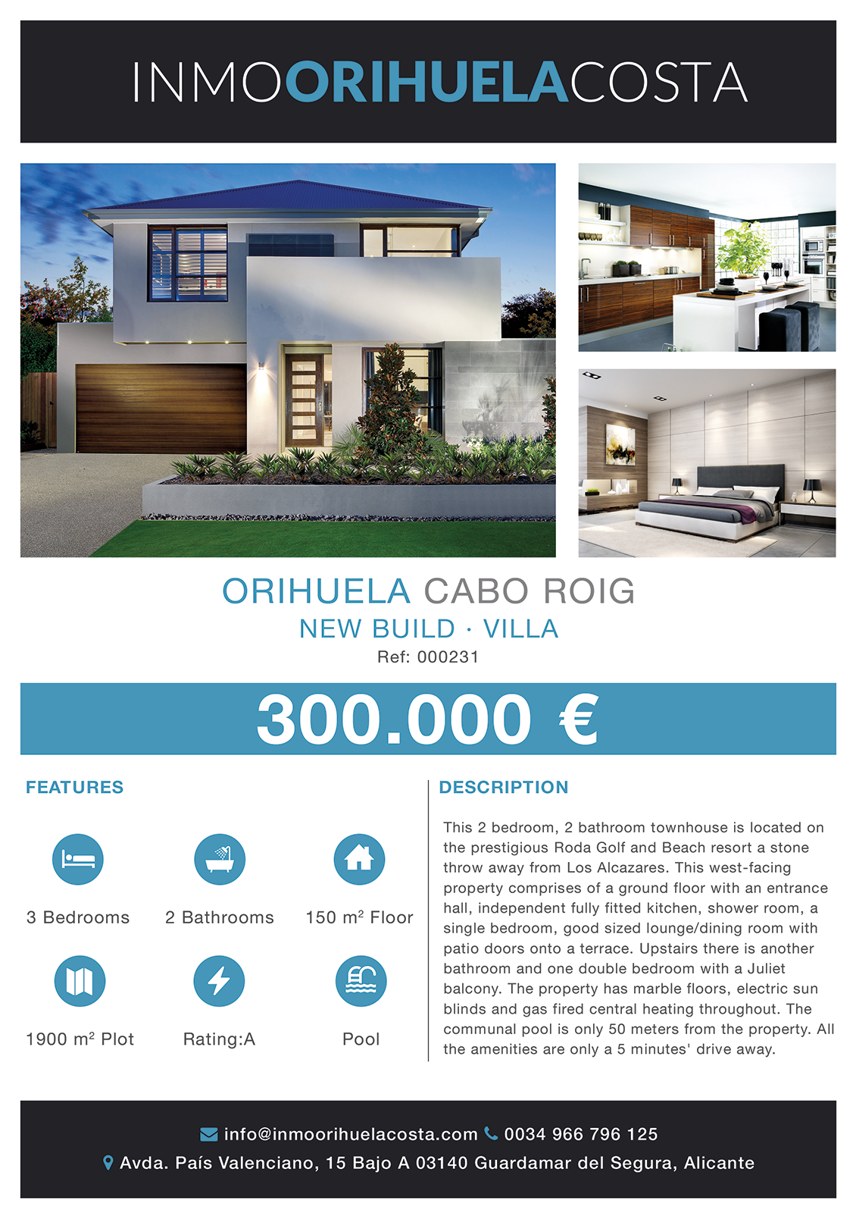

Newsletter
Do you plan to send your best properties through a newsletter? This is one of the online marketing actions that is working better today.
Here are the 3 designs we have prepared especially for you:
(See next page)

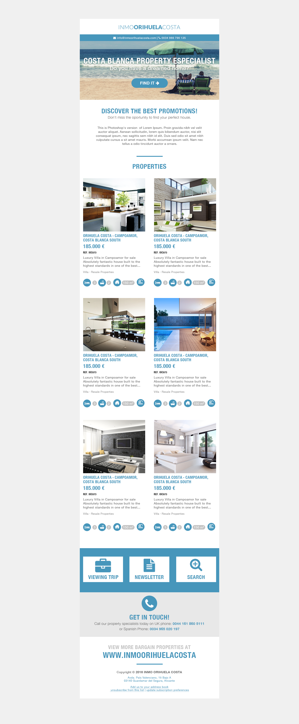
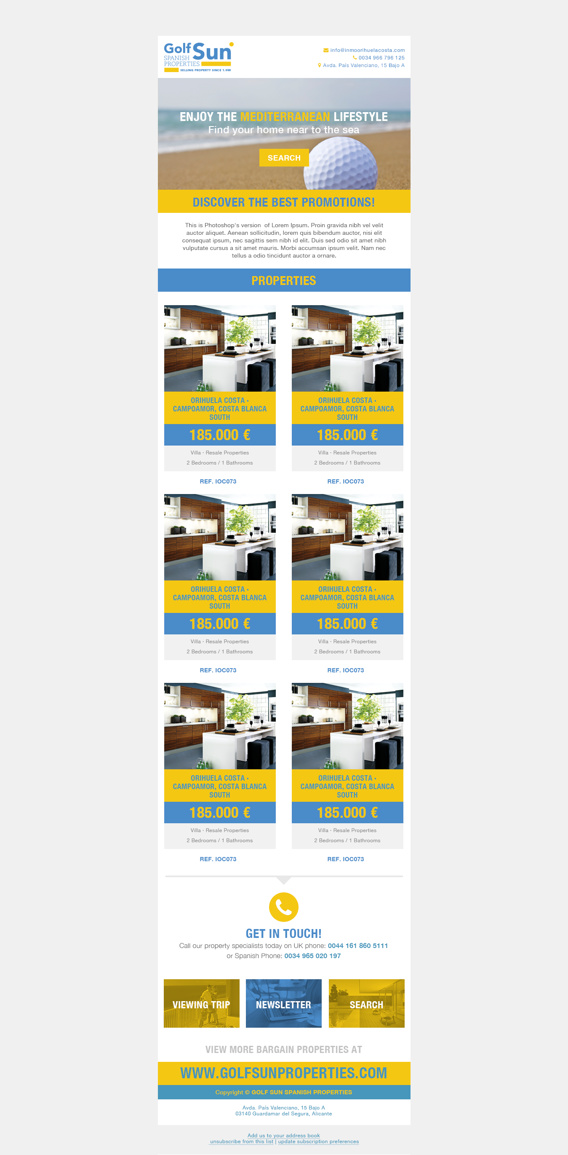
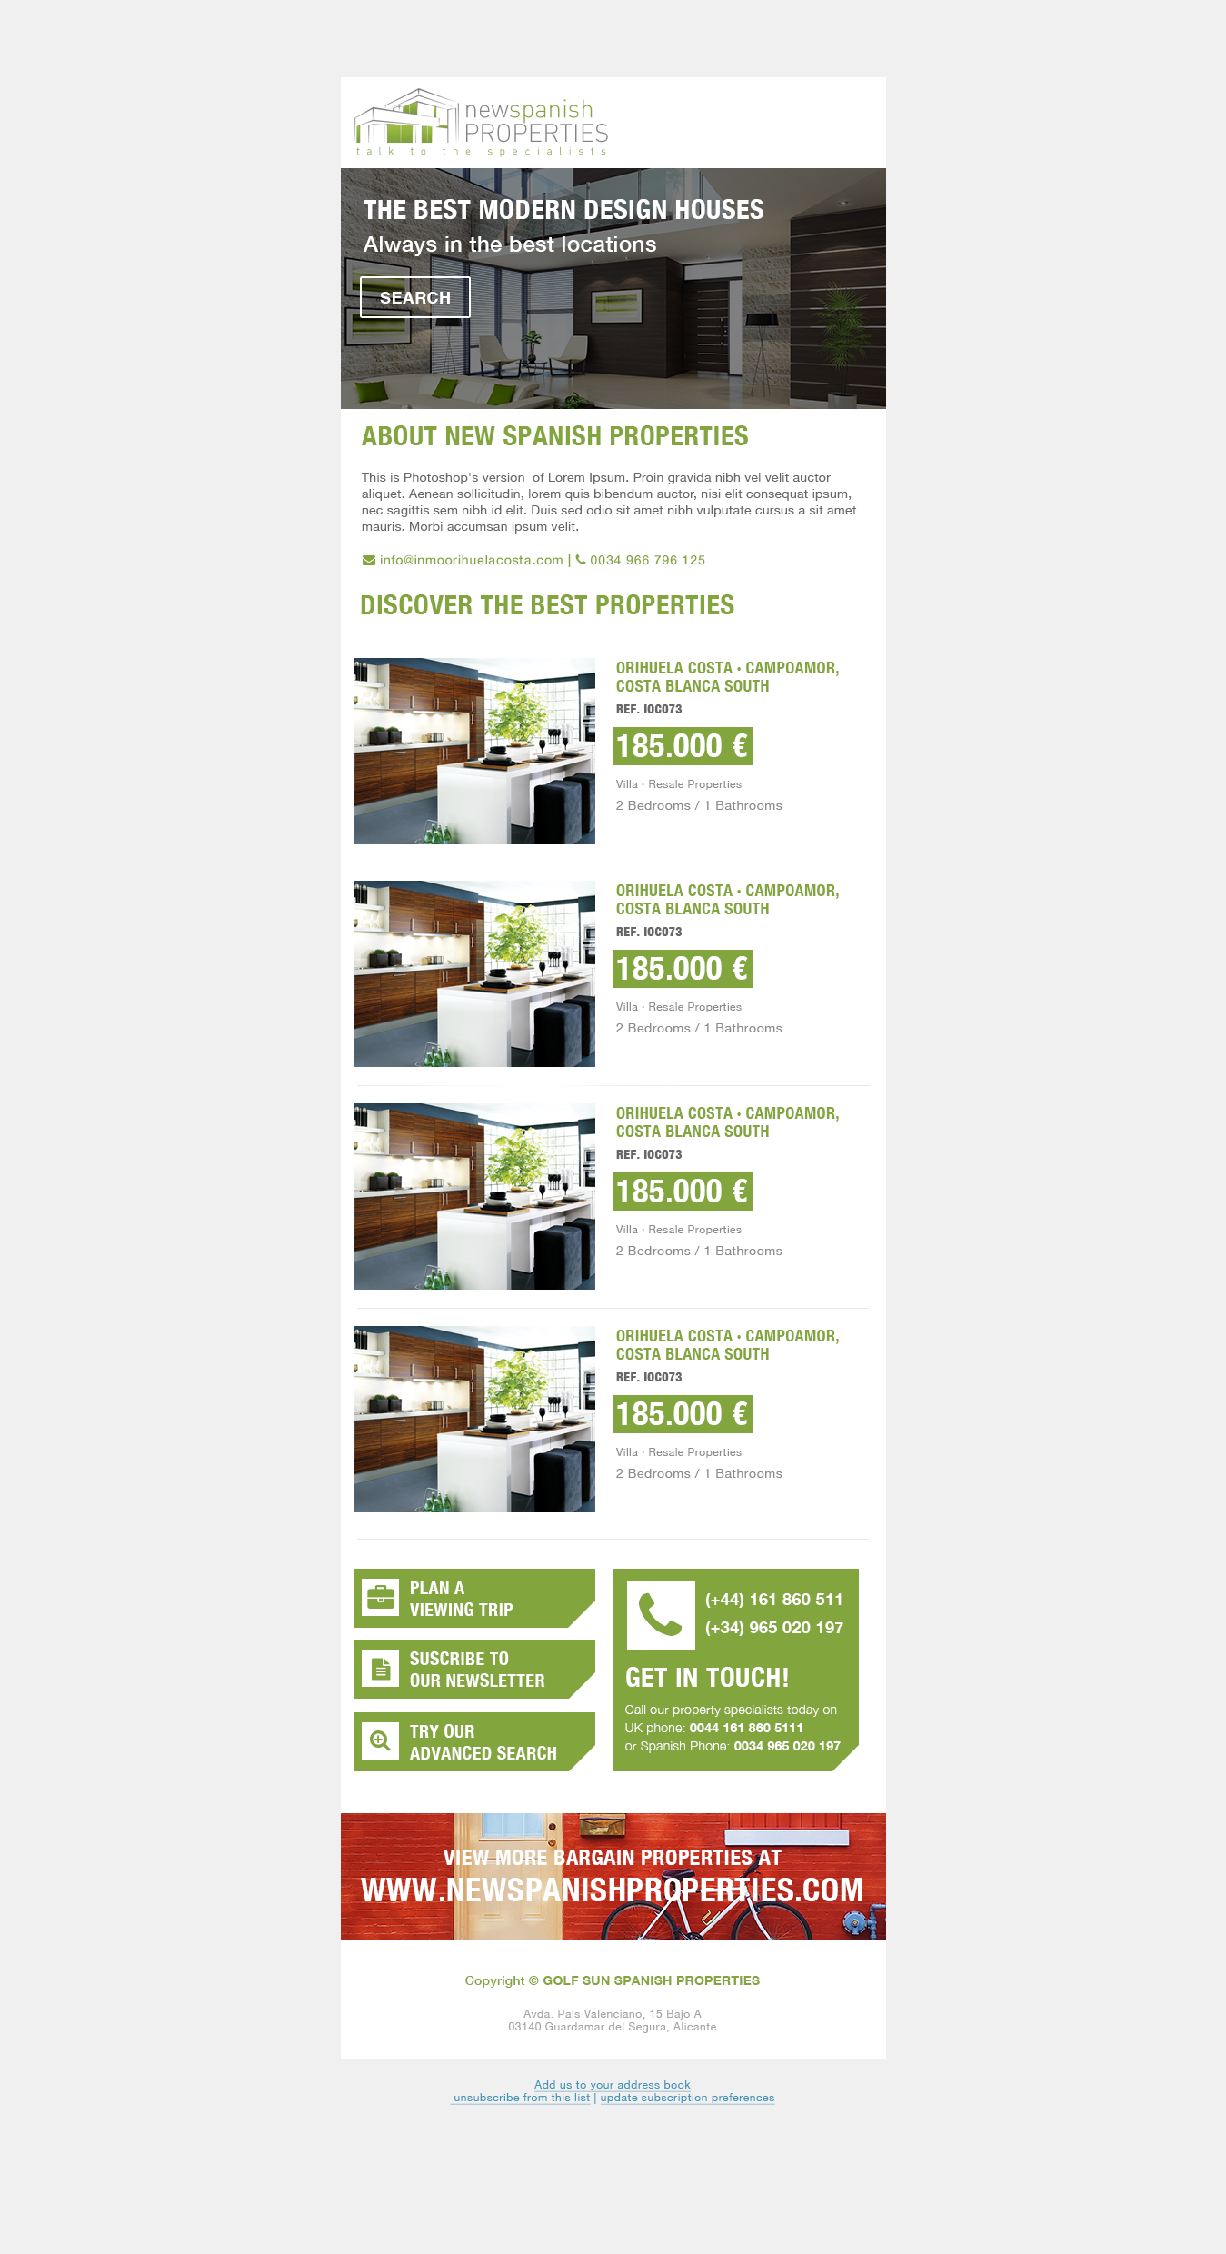

Printed graphic material
In case you have any kind of digital corporate graphic material, which is not digital, we would like to see it.
Whether magazines, leaflets, business cards, catalogs, posters .... We used to get an idea of your corporate image, and to follow web design lines in keeping with that image.



Contact:
- Address: Vicente Blasco Ibáñez, 58, Elche (Alicante).
- Phone: 966 222 989 / 966 161 282
- Schedule: L-J: 8h-14h / 16:30h-19:30h · V: 8h-14h
- Skype: miguel.mediaelx
- Email: clientes@mediaelx.net
- Web: http://www.mediaelx.net/

